User Manual

Analysis tools of Victoria State Accident

S5288771 Chi Pang Cheng

S5323472 Kwangseok Choi

## Initial Screen

On the menu bar, there are two button to select which is “File Open” and “Generate Chart”. If there is no CSV file loaded, button “Generate Chart” will set to disable. Other elements will set to Hide to prevent error except the log panel and progress bar at the bottom right panel. The purpose of log panel is allowing user to trace back to the pervious search or action.

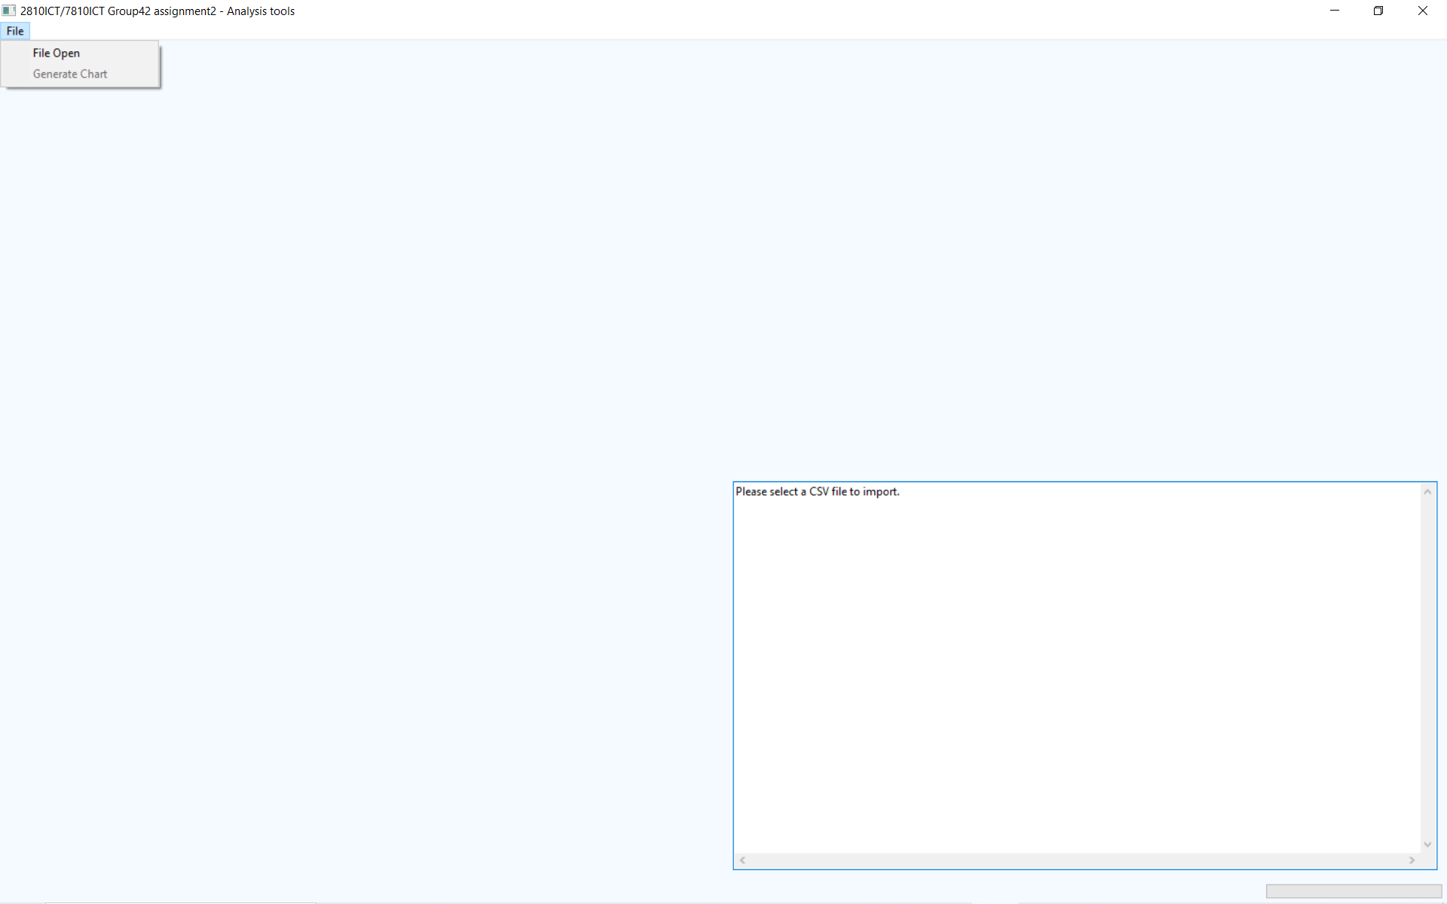

## Dialog for open file

After user clicked on the “Open File”, it will prompt a dialog for user to select CSV file to read.

## Loaded File

After loaded the file, the log panel will show the corresponding log message. All Elements in the frame will show as visible. Top left panel will show two buttons “Reset” and “Search”. Check boxes, labels and input fields are generated dynamically based on the header fields in the CSV file except “OBJECTID” and “ACCIDENT_NO” which is not relevant for statistics analysis. “Reset” button is to help user to uncheck all check boxes in one click. Top right panel is to show the data in the CSV and will be changed after user perform a search. Bottom left panel is used for statistics analysis, it will not show any statistics analysis under three conditions which are the first time of loading CSV, no field selected for search and selected more than five fields to search. There are few reasons for these restrictions which first reason is data are too large for analysis and cause slow performance. Second reason is that when too many fields selected, the statistics may not be related to the purpose of the search. Last reason is less fields selected can help user to focus on specify data that related to their search.

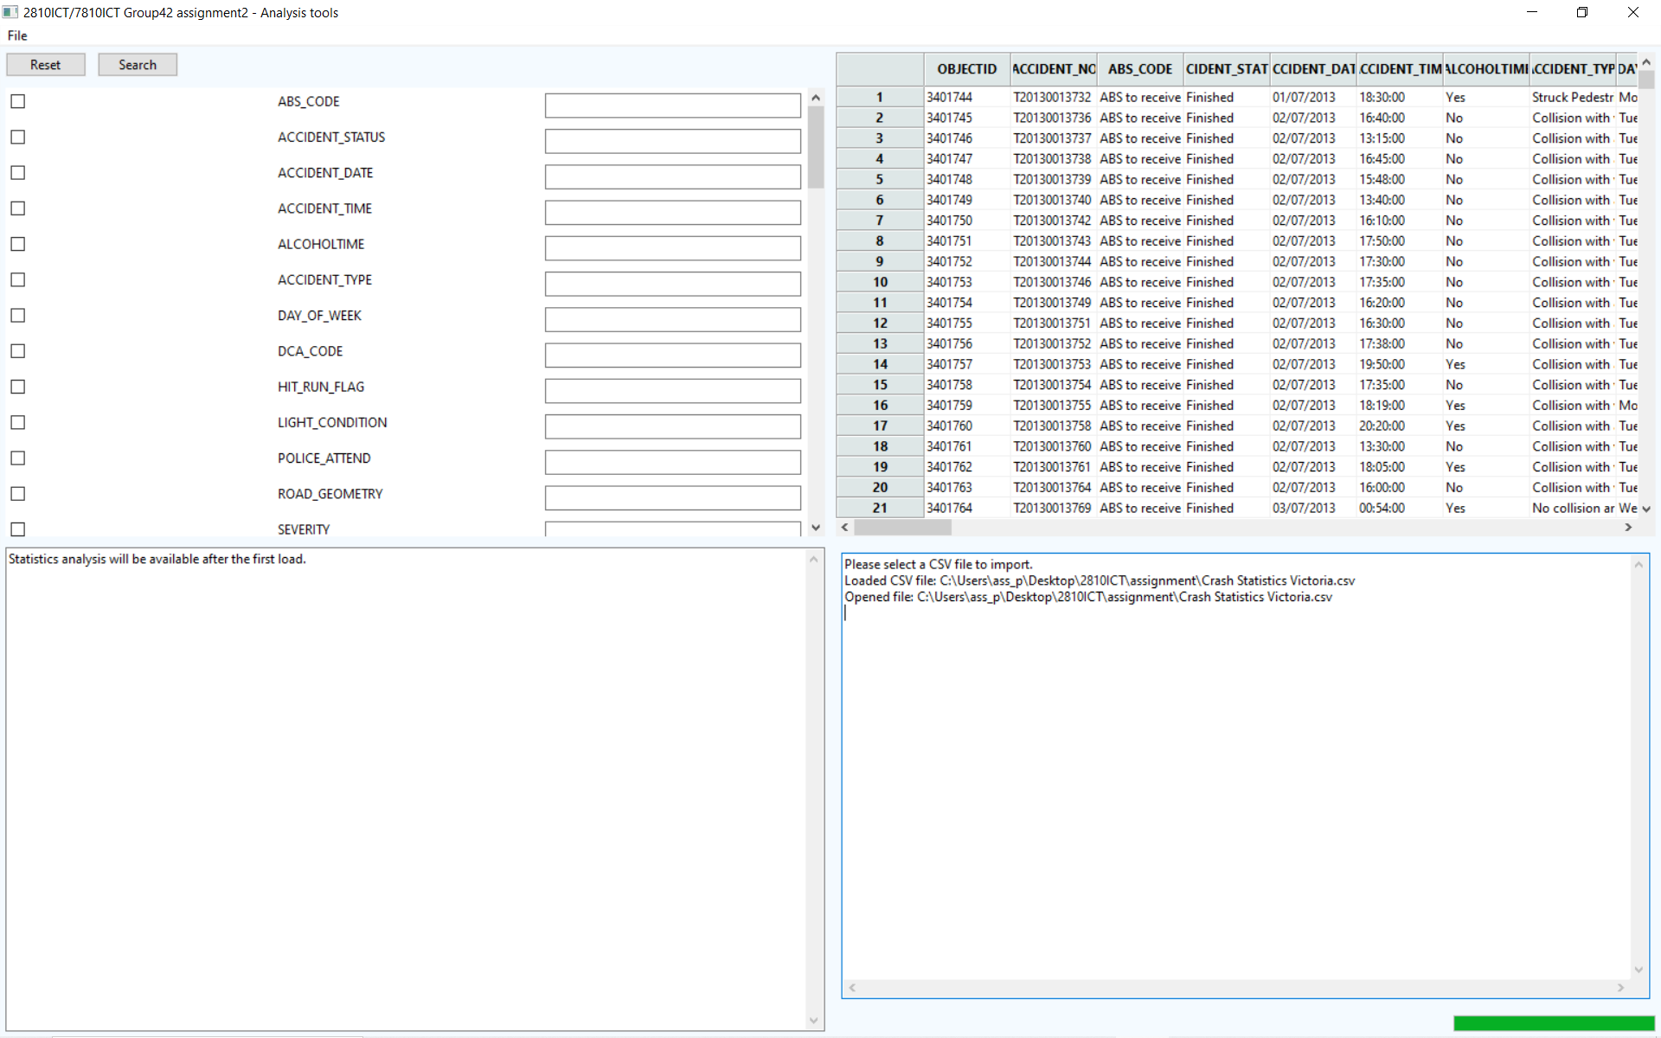

## Error message prompt

When user perform an invalid search, it will prompt an error message to notify the user. On the log panel, it will show the related information about each search

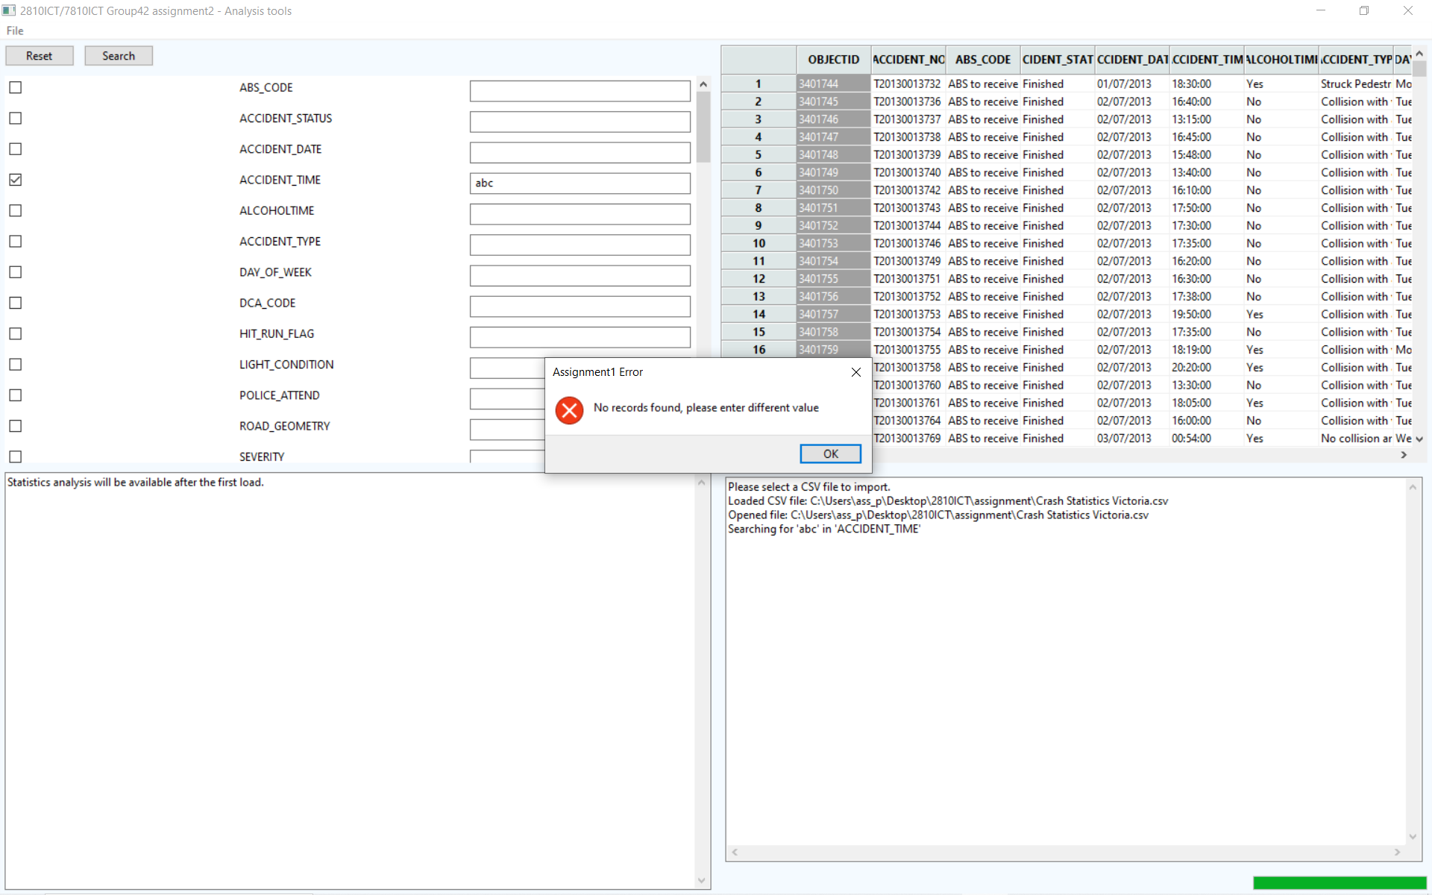

## Search successfully

Below image shows that bottom left panel updated when successfully retrieved data related to the search. It will show header name, value, count, and percentage based on the retrieved data. The log panel always recorded the log for the search which are “Searching for '2016' in 'ACCIDENT_DATE'” and “Search returned 14349 records”. The log will keep all records until user terminate the program.

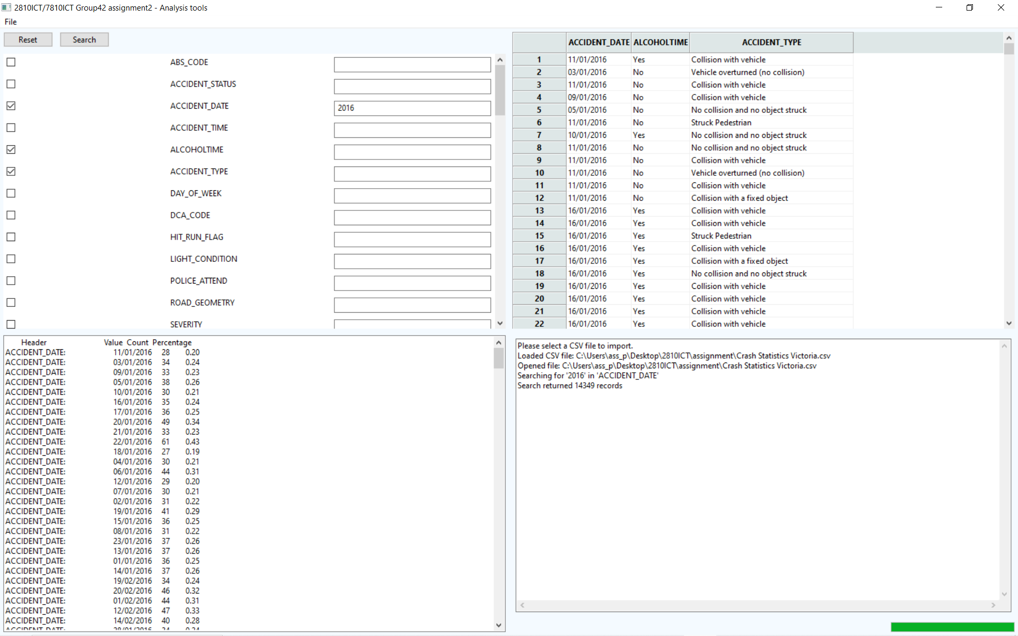

## Generate chart

Function of generate chart will use the data displayed in the grid. It is necessary for user to match the corresponding header name in the grid with the selection of X,Y axis. Y axes include all header names except date and time which are the only selection on X axes.

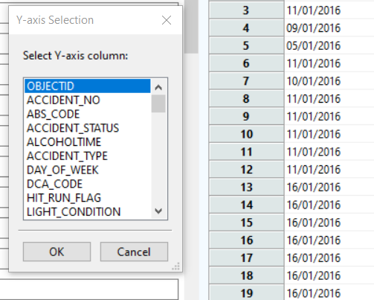

### Error prompt for header name mismatch

### Generate chart successfully

If user select different years for the search, chart will be generated by year.

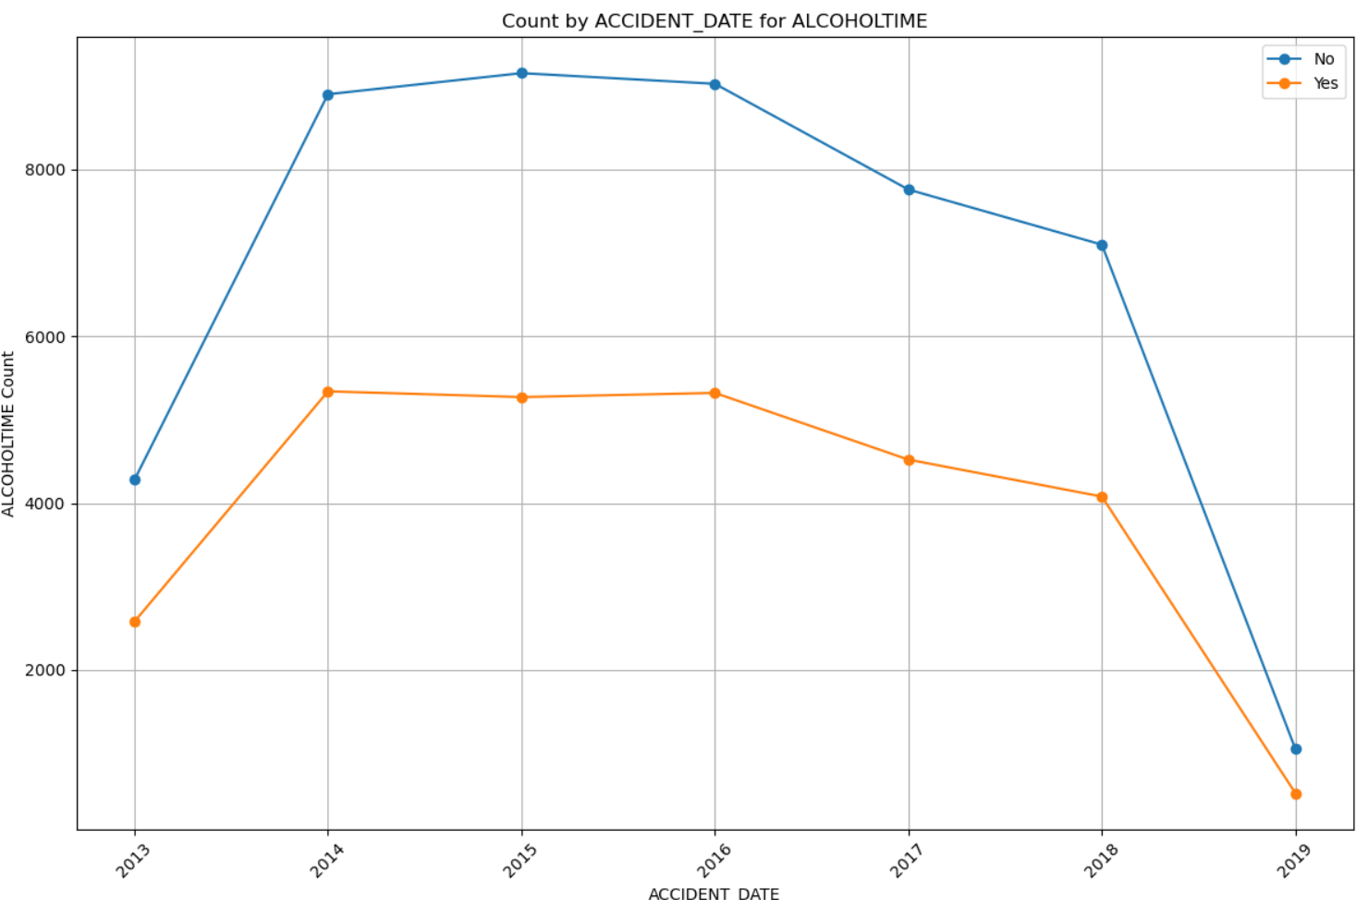

If user select different months within a year for the search, chart will be generated by month.

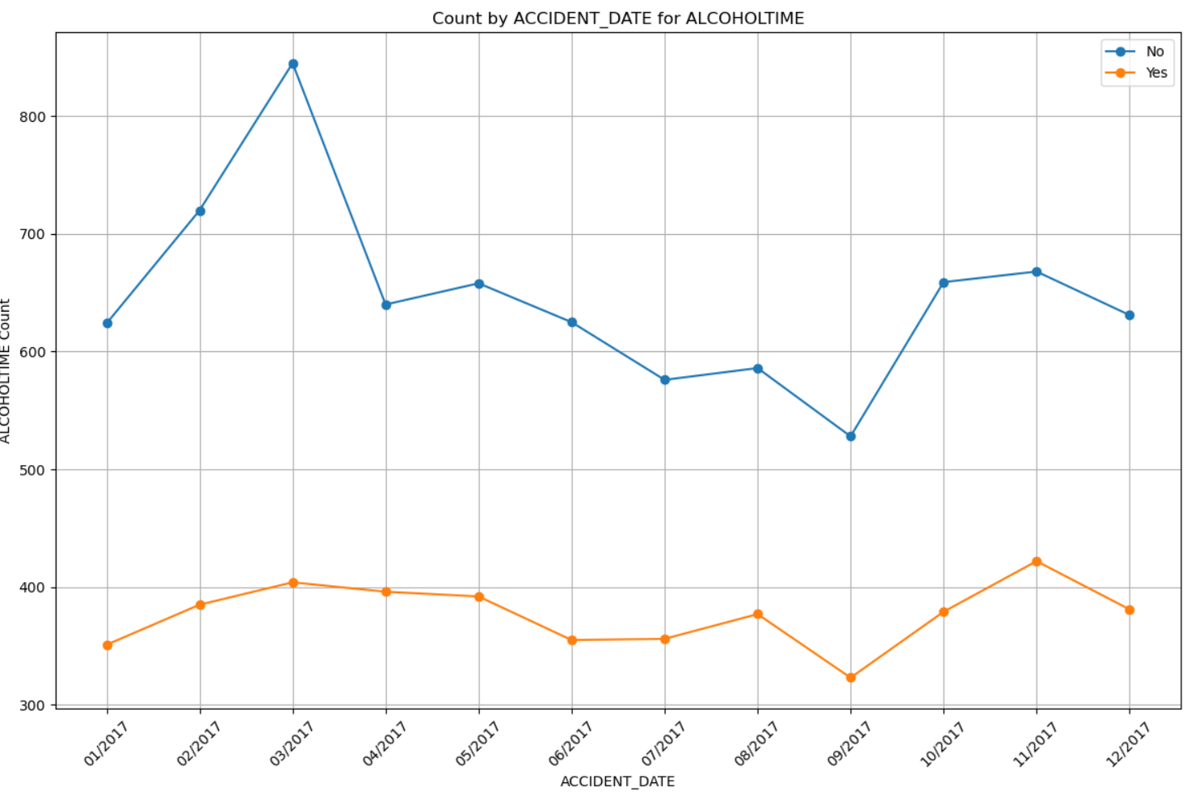

If user select different days within a month in a year for the search, chart will be generated by day.

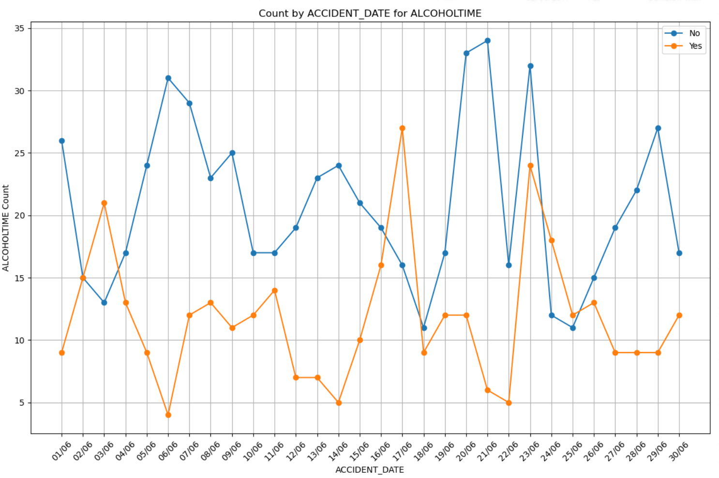

## Required Features

### For a user-selected period (in 2017), display the information of all accidents that happened in the period

Below images show the retrieved data in 2017 along with the accident type. There are 12281 records which 7813 records are Collision with vehicle with 63.62%, 1976 records are Collision with a fixed object with 16.09%, 1115 records are Struck Pedestrian with 9.08%, 623 records are Vehicle overturned (no collision) with 5.07%, 507 records are No collision and no object struck with 4.13%, 85 records are Struck animal with 0.69%, 54 records are Fall from or in moving vehicle with 0.44%, 105 records are collision with some other object with 0.85%, 3 records are Other accident with 0.02%.

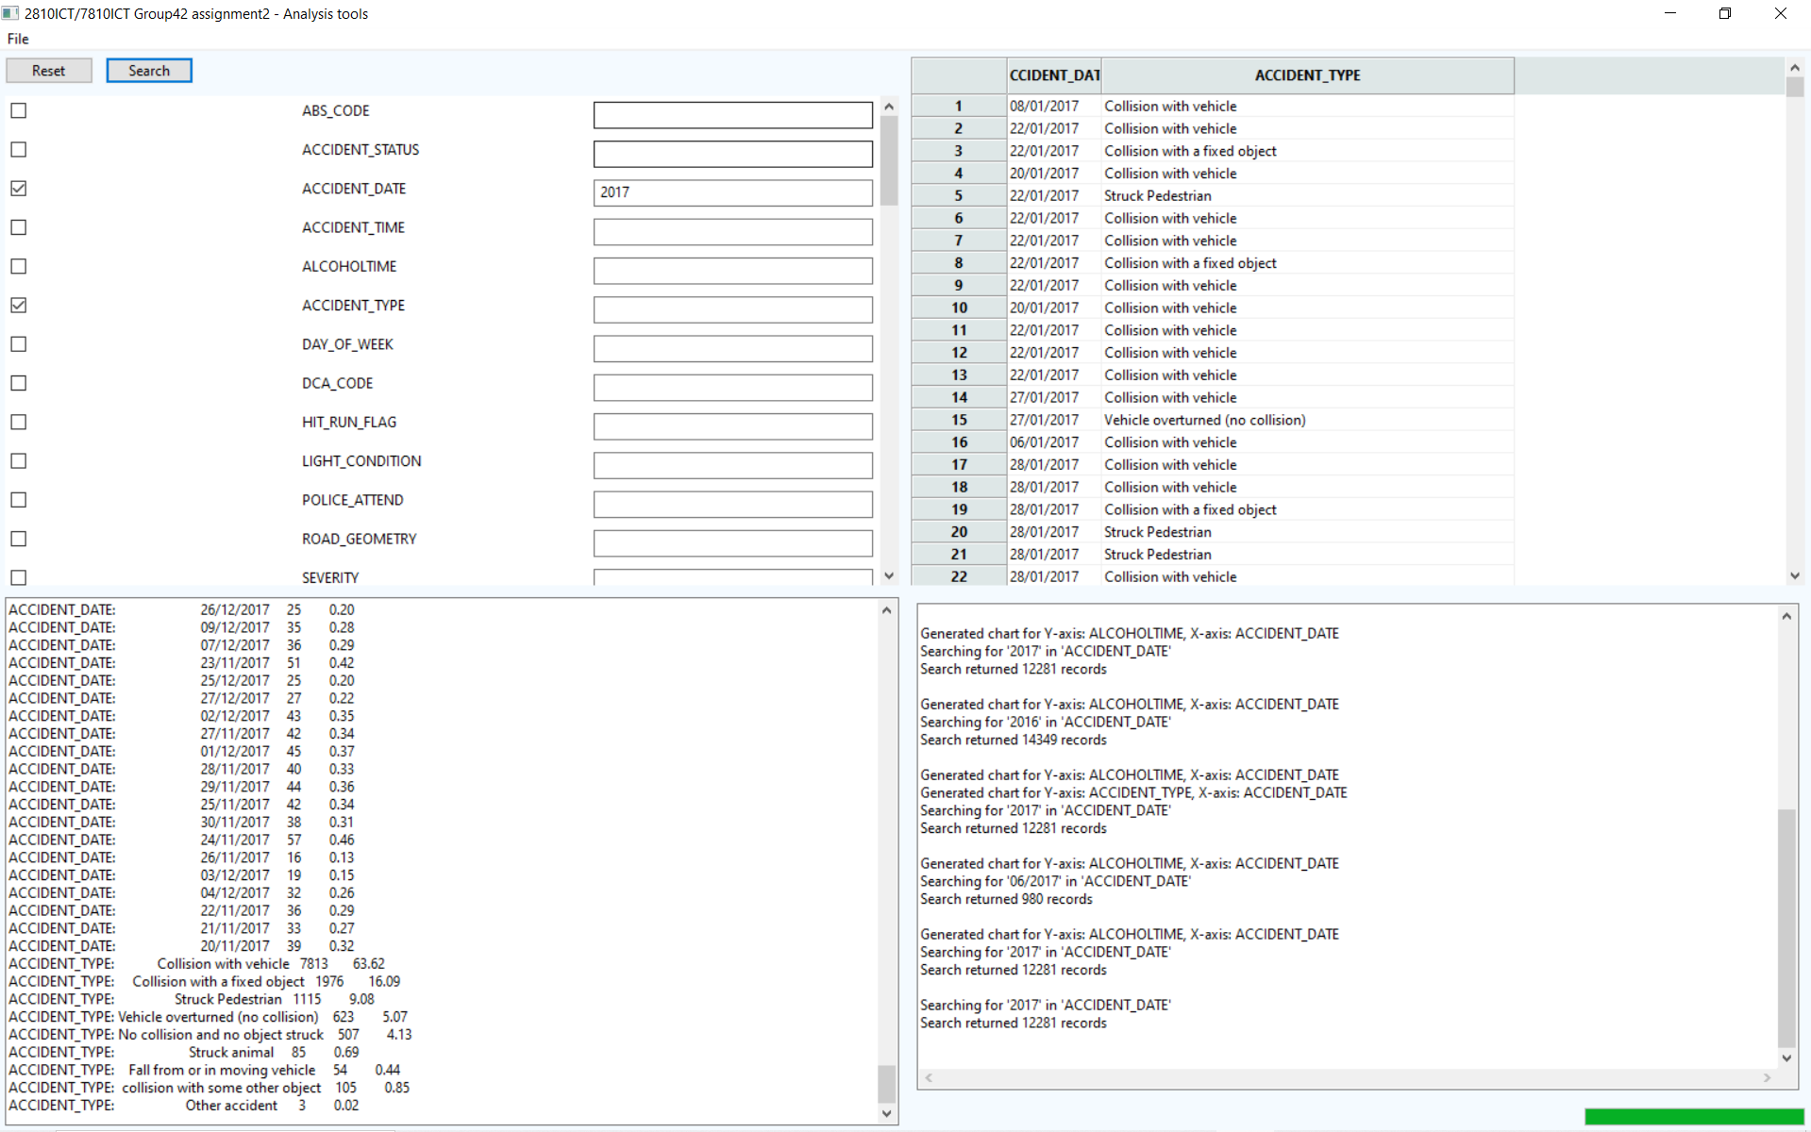

### 7.2 For a user-selected period, produce a chart to show the number of accidents in each hour of the day (on average).

Below image shows that user selected one year use ACCIDENT_STATUS to generate chart. It takes the accident number happened in each hour and divided by the range of the date. After that, it displayed the average accident number in hours.

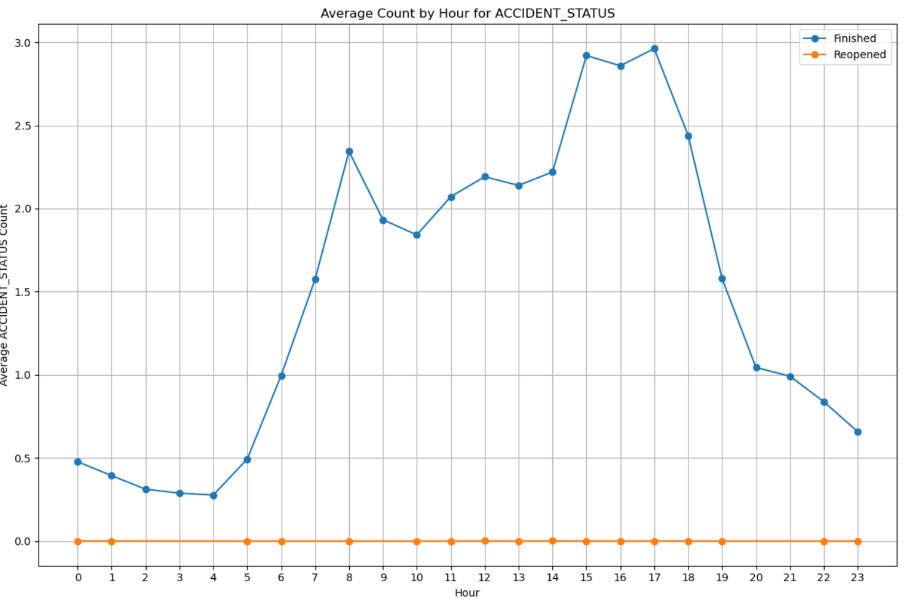

### For a user-selected period, retrieve all accidents caused by an accident type that contains a keyword (user entered), e.g. collision, pedestrian.

Below images shows that user entered “2016” in ACCDIENT_DATE, and “collision” and “pedestrian” in ACCDIENT_TYPE. At the bottom left panel, it shows the labels along with values, counts and percentages.

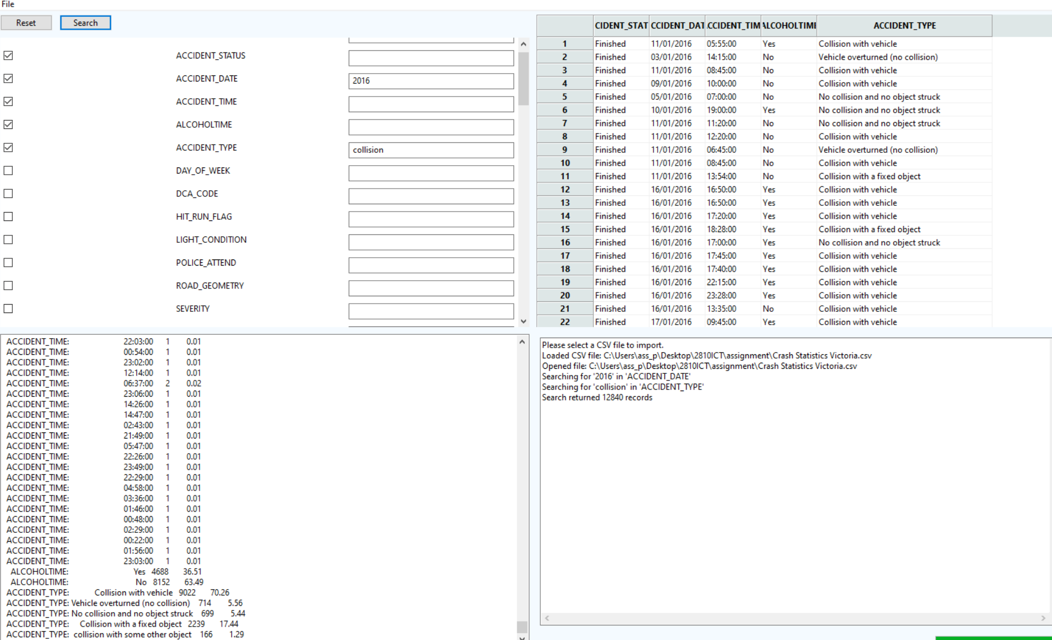

### 7.4 Allow the user to analyze the impact of alcohol in accidents – ie: trends over time, accident types involving alcohol, etc.

Below images show user entered “2016” in ACCDIENT_DATE, “Yes” in ALCOHOLTIME, and checked the box of ACCIDENT_TYPE. Therefore, the search takes the input and output to grid. The output in the grid will show all records in 2016 along with ACCDIENT_TYPE which is “Yes” in ALCOHOLTIME. After that, user can generate the chart by selecting ACCDIENT_TYPE as Y axes and ACCDIENT_DATE as X axes for analysis.

### 7.5 analyse the accident frequency in different locations

Below images show user want to display REGION_NAME_ALL within 2016 to analyse the frequency. If user want to specifically analyse different locations, user can enter the value in the input text box next to the label to search.

